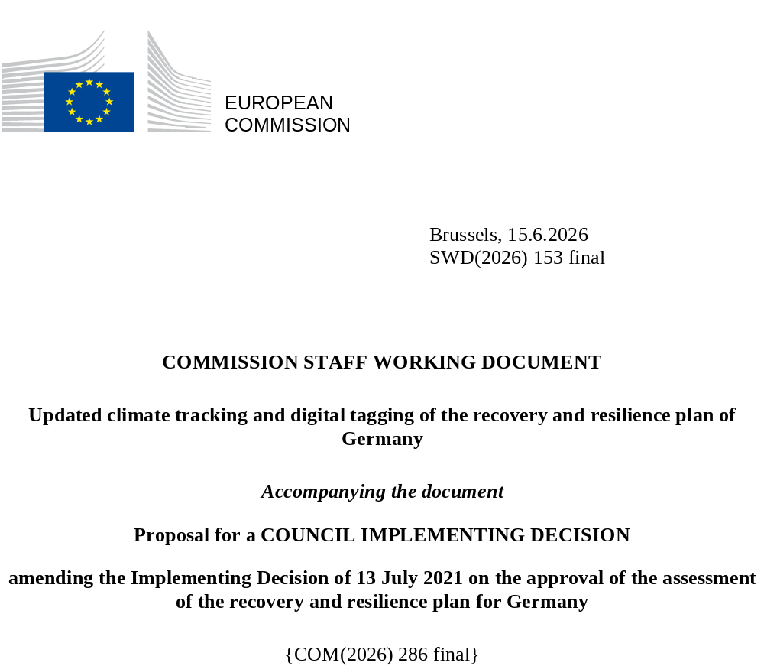

Updated climate tracking and digital tagging of the recovery and resilience plan of Germany
The table below presents the detailed application of the climate tracking and digital tagging methodologies set out respectively in Annexes VI and VII to Regulation (EU) 2021/241 in the modified German recovery and resilience plan.
Int. Field = intervention field.
Coeff. = Coefficient for the calculation of support to climate change objectives and to digital transition, on the basis of Annex VI and Annex VII of the RRF Regulation.
New or revised measures are highlighted to distinguish them from the unchanged measures in the RRP
Measure ID | Measure/Sub-Measure Name | Budget (EUR m) | Climate |  | Digital
Measure ID | Measure/Sub-Measure Name | Budget (EUR m) | Int. Field | Coeff. | Int. Field | Coeff.
1.1.1.1 | Hydrogen projects within the framework of IPCEIs: part 1 | 470.6 | 022 | 100%
1.1.1.2 | Hydrogen projects within the framework of IPCEIs: part 2 | 470.6 | 027 | 100%
1.1.1.3 | Hydrogen projects within the framework of IPCEIs: part 3 | 470.6 | 033 | 100%
1.1.2 | Funding programme for decarbonisation in industry | 55 | 022 | 100%
1.1.4 | Project-related climate protection research | 50.4* | 022 | 100%
1.1.5 | Flagship projects for research and innovation in the context of the National Hydrogen Strategy | 588.2* | 022 | 100%
1.1.6 | Federal support for efficient heat networks | 315.8 | 034bis0 | 100%
1.2.1 | Support for the construction of charging infrastructure | 637.8 | 077 | 100%
1.2.2.1 | Funding for the development of electro-mobility: R & D, mobility concepts | 42* | 022 | 100%
1.2.2.2 | Funding for the development of electro-mobility: zero-emission vehicles | 21* | n/a** | 100%
1.2.3.1 | Support for the replacement of the private vehicle fleet: zero-emission vehicles | 2764 | n/a** | 100%
1.2.3.2 | Support for the replacement of the private vehicle fleet: hybrid vehicles. | 1 296 | n/a** | 40%
1.2.4 | Extension of the initial registration period for granting the ten-year tax exemption for purely electric vehicles | 295 | n/a** | 100%
1.2.5 | Support for purchases of buses with alternative propulsion | 1085 | na** | 100%
1.2.6.1 | Support to promote alternative rail propulsion: electric rolling stock | 129.9 | 072bis | 100%
1.2.7.1 | Promotion of the industries involved in hydrogen and fuel cell applications in transport: part 1 | 458.3* | 022 | 100%
1.2.7.2 | Promotion of the industries involved in hydrogen and fuel cell applications in transport: part 2 | 168.1* | n/a** | 100%
1.3.2 | Municipal living labs for the energy transition | 57 | 025 | 40%
1.3.3.1 | Building renovation: federal funding for energy-efficient buildings: medium-depth level renovations | 2 500 | 025bis | 100%
1.3.3.2 | Building renovation: federal funding for energy-efficient buildings: individual renovation measures | 1 595 | 025 | 40%
2.1.1.1 | Innovative data policy for Germany: overall strategy high-performance computing | 7.2* |  |  | 021quater | 100%
2.1.1.2 | Innovative data policy for Germany: ideas competition and piloting of data fiduciaries | 37.3* |  |  | 009bis | 100%
2.1.1.3 | Innovative data policy for Germany: research network depersonalisation & support programme anonymisation | 70.7* |  |  | 009bis | 100%
2.1.1.5 | Innovative data policy for Germany: National Research Data Infrastructure (Nationale Forschungsdaten-infrastruktur) and data literacy | 38.2* |  |  | 108 | 100%
2.1.1.6 | Innovative data policy for Germany: PhD programme in data sciences | 5.5* |  |  | 108 | 100%
2.1.1.7 | Innovative data policy for Germany: incentives for the after-use of data | 4.2* |  |  | 108 | 100%
2.1.1.8 | Innovative data policy for Germany: long-term competence monitoring | 8.0* |  |  | 108 | 100%
2.1.1.9 | Innovative data policy for Germany: data literacy courses for students | 4.8* |  |  | 108 | 100%
2.1.1.10 | Innovative data policy for Germany: toolbox data literacy | 8.5* |  |  | 108 | 100%
2.1.1.11 | Innovative data policy for Germany: innovation process ‘architectures, institutions and spaces for the data society’ | 1.6* |  |  | 108 | 100%
2.1.1.12 | Innovative data policy for Germany: establishment of data cooperations | 2.5* |  |  | 011 | 100%
2.1.1.13 | Innovative data policy for Germany: data literacy in the federal administration: data laboratories, Chief Data Scientists and competence building | 245.1* |  |  | 108 | 100%
2.1.2 | IPCEI microelectronics and communication technologies | 1 500 |  |  | 021quater | 100%
2.1.3.1 | IPCEI Next Generation Cloud Infrastructure and Services (IPCEI CIS): emission reduction and energy efficiency criteria | 141.5 | 055bis | 40% | 021quater | 100%
2.1.3.2 | IPCEI Next Generation Cloud Infrastructure and Services (IPCEI CIS) | 141.5 |  |  | 021quater | 100%
2.2.1.1 | Vehicle manufacturer/supply industry investment programme: digitalisation of production as a boost for productivity and resilience: greenhouse gas emission reduction or energy efficiency criteria | 650 | 010ter | 40% | 010ter | 100%
2.2.1.2 | Vehicle manufacturer/supply industry investment programme: digitalisation of production as a boost for productivity and resilience | 427.1 |  |  | 010ter | 100%
2.2.1.3 | Vehicle manufacturer/supply industry investment programme: new innovative products as the key to vehicles and mobility of the future - automated driving | 392.7 |  |  | 009bis | 100%
2.2.1.5 | Vehicle manufacturer/supply industry investment programme: finding joint solutions, building regional innovation clusters | 232.4 |  |  | 019 | 40%
2.2.2 | Federal programme ‘Building continuing education and training networks (CET networks)’ | 31.9* |  |  | 016 | 40%
2.2.3 | Digitalisation and Technology Research Centre of the Bundeswehr (dtec.bw) | 588.2* |  |  | 009bis | 100%
2.2.4 | Promoting the digitalisation of rail by replacing conventional interlocking/fast-track programmes to speed up the roll-out of the ‘Digital Rail Germany’ (SLP)’ | 500 | 070 | 40% | 070 | 100%
3.1.1 | Investment programme for teacher devices | 420.2* |  |  | 012 | 100%
3.1.2 | Education platform | 529.4* |  |  | 012 | 100%
3.1.3 | Educational centres of excellence | 172.3* |  |  | 108 | 100%
3.1.4 | Modernisation of the Federal Armed Forces’ educational and training facilities | 84* |  |  | 012 | 100%
4.1.3 | Apprenticeships support | 282 |  |  | 099 | 40%
4.1.5 | Digital pension overview | 28.8* |  |  | 011 | 100%
5.1.1 | Strengthening the digital and technical resources of the public health service | 684* |  |  | 011 | 100%
5.1.2 | Programme to future-proof hospitals | 3 000 |  |  | 095 | 100%
6.1.1 | European identity ecosystem | 168.1* |  |  | 011 | 100%
6.1.2 | Digitalisation of the administration – implementation of the Online Access Act | 2 521* |  |  | 011 | 100%
6.1.3 | Digitalisation of the administration – modernisation of registers | 231.1* |  |  | 011 | 100%
7.1.1 | Scale-up: Building renovation: federal funding for energy-efficient buildings: individual renovation measures | 2 090 | 025 | 40%
7.1.2.1 | Support programme for light- and heavy-duty zero-emission transport: vehicles | 125.5 | n/a** | 100%
7.1.2.2 | Support programme for light- and heavy-duty zero-emission transport: electric recharging and hydrogen refueling stations | 96.4 | 077 | 100%
7.1.3 | Digital platform for processing authorisation requests for the hydrogen core network | 99 | 033 | 100% | 011 | 100%
Note: Cells with green shading reflect changes compared to the staff working document adopted in December 2025, SWD(2025) 430 final.
* Budget figures are rounded to hundred thousands. The table shows the cost of the measures without VAT. For most measures this equals the cost included in the recovery and resilience plan. However, for measures marked with an asterisk (*), Germany indicated when submitting the recovery and resilience plan in April 2021 that their cost may include VAT, and in this table the cost is shown while taking away the full amount of potential VAT for these measures (assuming that the maximum VAT rate of 19% fully applies).
** The ‘Methodology for climate tracking’ annexed to the Recovery and Resilience Facility Regulation does not set out intervention fields that would allow for climate or environmental tracking of electric vehicles or plug-in hybrid vehicles, except for vehicles for urban transport falling under intervention field 074. According to Article 18(4)(e) of the Regulation, the methodology should however ‘be used accordingly for measures that cannot be directly assigned to an intervention field listed in Annex VI’. In this context, the Commission has applied a 100% climate contribution coefficient for zero-emission vehicles of all categories (this includes battery electric and fuel cell/hydrogen-powered vehicles); a 40% climate contribution coefficient for plug-in hybrid light-duty vehicles; and, in line with the criteria under the Taxonomy Regulation, a 100% climate coefficient for low-emission heavy-duty vehicles.
*** While the estimated cost of Germany’s recovery and resilience plan exceeds the total allocation of non-repayable financial support to Germany, Germany will ensure that all spending related to the measures mentioned in this table as contributing to climate objectives are fully financed by the funds from the Recovery and Resilience Facility.
**** Reforms and investments in the REPowerEU chapter are not taken into account when calculating the plan’s contribution to the digital target requirement set by Regulation (EU) 2021/241.

